
A 10

Sreenidhi Institute of Science & Technology
(An Autonomous Institution)
Code No: 102EP04
M. TECH. I – Year I – Semester Examinations, March, 2011 (Regular)
COMPUTER METHODS IN POWER SYSTEMS

Time: 3 Hours Max. Marks : 60

Note : No additional answer sheets will be provided.

* * * * *
Part-A (Objective Type)
Max.Marks:10

Answer all the QUESTIONS.

- Write the Performance equation of a Primitive network both in impedance and admittance form.

- Represent a 3 – ph Primitive network in admittance form and write its performance equation.

- The impedance per phase of a 3 – ph transmission line on a base of 100 MVA, 100 kV is 2 p.u. what is the value of this impedance on a base of 400 MVA and 400 kV ?

- The performance equation of a two bus power system is _{BUS} = { Y_{BUS} } V_{BUS} and it is given as follow : Determine 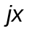.
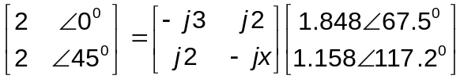

- Define off nominal turns ratio of a transformer.

- What do you mean by sparsity of a Y_{BUS}.

- Define the transient stability.

- Define Slack Bus.

- Is inertia constant M of an alternator depends on the size of machine ?

- Write the symmetrical transformation matrix ( TS) used in power system analysis.

Part – B (Subjective Type)
Max.Marks: 50
Answer any Five. All questions carry equal marks.

- Obtain Z_{BUS} of a graph of a power system network shown in fig 1, using algorithm for Z_{BUS} method.
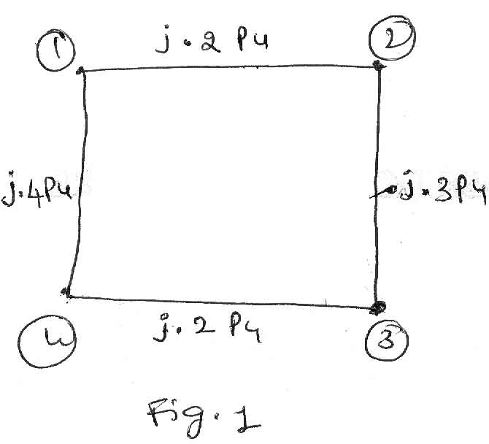
The line impedances are given in p.u..

- a. Develop expression for short circuit analysis in phase quantities. [ 5 ]

b. Using above expressions explain how LG fault and 3-phase to ground fault is analyzed. [ 5 ]

- A 2 bus system shown in Fig 2.
Y₁₁ = Y₂₂ =1.6 -80⁰ p.u. and Y₂₁ = Y₁₂ = 1.9 100⁰ p.u. Determine the voltage at bus - 2 by Gauss – Seidal method.
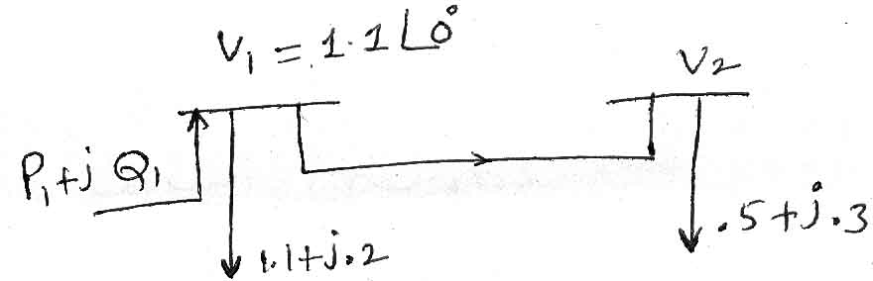
Fig 2.

- Explain in detail about the Sparsity Techniques used to obtain Z _{BUS} of a power system network.

- a. Explain and derive the swing equation. [ 5 ]

  - Explain about Runge – Kutta method with Flowchart. [ 5 ]

- Obtain the block diagram of a two area controlled power system network and solve the necessary equations.

- Write short notes on :

- Short circuit analysis [ 5 ]

- Load flow analysis of Power System Network. [ 5 ]

------

